Charity
Our Catholic faith teaches us to, “Love thy neighbor as thyself.” Knights recognize that our faith in God compels us to action. The Knights of Columbus have donated more than $1.55 billion in the last 10 years to charitable causes and contribute over 71.5 million service hours annually.
Unity
Working together, we can do more than all of us, individually. Knights know that, so we support one another. As a Knight, you can count on the support and encouragement of your Brother Knights as you work to make life better in your parish and community.
Fraternity
Fr. Michael J. McGivney founded the Knights, in large part, to provide assistance to families left behind when the father died, often prematurely. The Order’s top-rated insurance program continues to do this today. In addition, you can count on your Brother Knights to help our families in times of sickness, disability, or distress.
Patriotism
The importance of supporting God, country, and our veterans is not lost on the Knights. Tasked with being strong patriots and exemplary citizens, Knights all over the world turn out for parades and special occasions in full regalia.

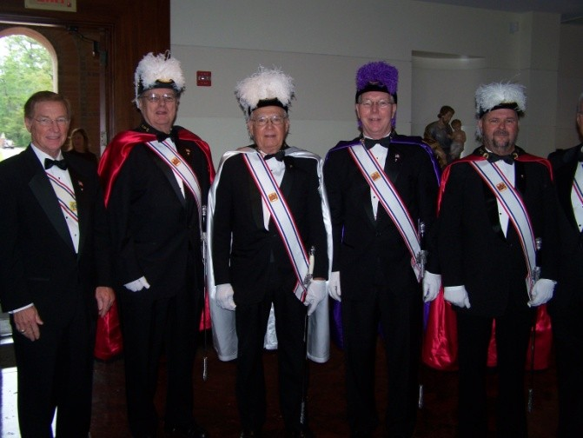
Church
Supporting the Catholic Church has been a hallmark of the Knights of Columbus since its foundation in 1882. From funding the restoration of the façade of St. Peter’s Basilica in Rome to participating in local parishes, the Knights serve the Church in countless ways.
Our Council
- donates funds to St. Anthony’s Bread & St. Vincent DePaul
- has members serving as EMs, ushers, greeters, lectors, etc
- supports seminarians & clergy
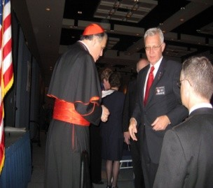
Council
Our councils are very busy with charitable events happening all year long. We work hard, but have fun, too, because we are spending time with like-minded men. We make time for some social events too, such as golf, picnics, and dinners. Officers guide our council and make sure everyone is informed.
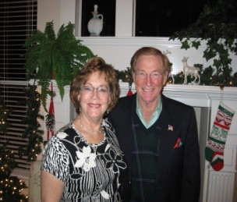
Our Council . . .
- helps fund & work the Cardinal’s Shepherd Cup Golf Tournament
- enjoys Christmas parties, family picnics, & before-meeting meals
- puts on the annual Lenten Fish Fry
Community
Community is the world immediately around us - the place we call home. We have a role in shaping the community around us and it offers limitless opportunity for action that can be seen, felt and appreciated for its true worth.
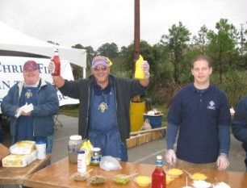
Our Council . . .
- Donates to Habitat for Humanity
- serves meals for Special Olympics Bowling & Track & Field events
- donates to the KofC National Wheelchair Program

Pro-Life
Every life is sacred, from conception to natural death. As Knights, we are called to defend the dignity of human life at every stage and to build a ‘culture of life’ and a civilization of love. Knights and our families assist pregnant women in need, tend to the handicapped and care for the elderly.
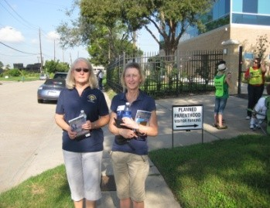
Our Council . . .
- donates funds for the aid of expectant mothers (PACN)
- supports Pro-Life Billboard Project
- marches at Houston’s Planned Parenthood center

Family
The family stands at the core of the Knights of Columbus’ beliefs and ideals as a Catholic organization. The Knights celebrate and emphasize the importance of the family through our top-rated insurance program, family friendly events, striving to lead our families into more holy lives, and creating loving and faithful homes.
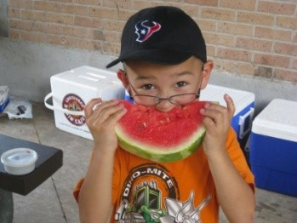
Our Council . . .
- works side-by-side with our Ladies’ Auxiliary
- promotes spiritual families with Corporate Communion events
- hosts the annual Ice Cream Social

Youth
Today’s youth are the leaders of tomorrow. They are looking for challenges, responsibility, faith, and trust. For young men 18 and under, the Squire Program builds civic and religious leaders. We help them grow in their faith to better meet the challenges ahead.
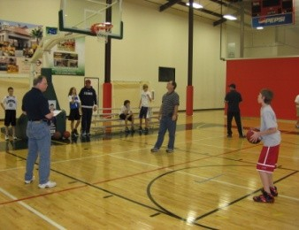
Our Council . . .
- gives scholarships to HS seniors
- has a poster contest on Substance Abuse Awareness
- hosts the annual Edge & Altar Servers Appreciation Dinners
Knights of Columbus
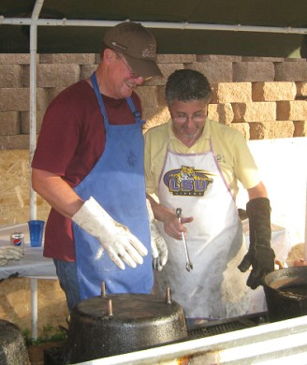
The Knights of Columbus stand for a world of wonderful things. Our membership is over 1.85 million Catholic men, in more than 14,000 councils. The Knights of Columbus is the largest Catholic men’s fraternal organization in the world. Dedicated to the principles of Charity, Unity, Fraternity and Patriotism, the Knights of Columbus make a difference in the faith and families around the world, within The Woodlands, and right here at St. Anthony’s of Padua Catholic Church.
Council # 12327 at St. Anthony’s serves the Church and the community in many ways and we have a great time doing it. Our programs, within Church, Community, Council, Pro-Life, Family and Youth, build strong bonds among participating Knights.
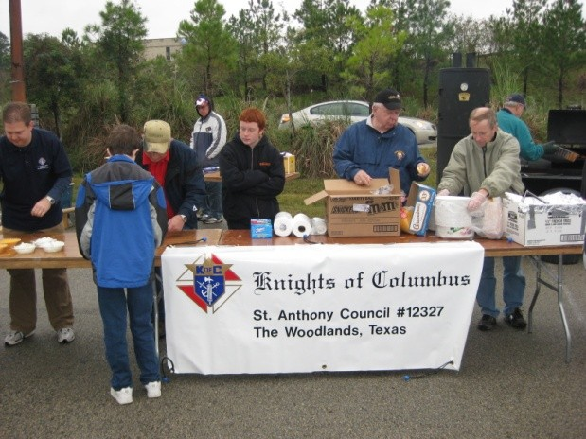
If you would like to support your church and community, grow in faith, believe in the Sanctity of Life and Christian family values, and want to associate with others who share these same goals, then consider joining the Knights of Columbus at St. Anthony of Padua.

COUNCIL # 12327
OFFICERS & DIRECTORS

Chaplain Deacon Bob Keller Grand Knight Barry Sinclair
Deputy Grand Knight Larry Pellerito
Chancellor Carlos Landa
Financial Secretary Jerome Carr Treasurer Alan Spencer
Recorder Richard McQuaide
Warden Ben Van Staveren
Advocate Steve Lastapes
Lecturer Larry Pellerito
Inside Guard Robert Vadas
Outside Guard Chris Dragone
1-Year Trustee William Lessmann
2-Year Trustee Gary Boye
3-Year Trustee Jeff Gillispie
Membership Director Tony Maniscalco
Columbian Squires Counselor Chris Nelli
Program Director Larry Pellerito
Church Director Camilo Reyes
Community Director JP Garcia
Council Director Chuck Meyer
Pro-Life Director Adam Martinez
Family Director Zach Scardino
Youth Director Mike Day

For General Information
Barry Sinclair (281) 451-8899
barry.sinclair@sbcglobal.net

Interested in Joining or Learning More?
Tony Maniscalco (623) 606-2585
sonnyboywh@yahoo.com

Interested in Columbian Squires?
Chris Nelli (281) 419-9840
christopher_nelli@huntsman.com

Visit us at
www.kofc12327.org

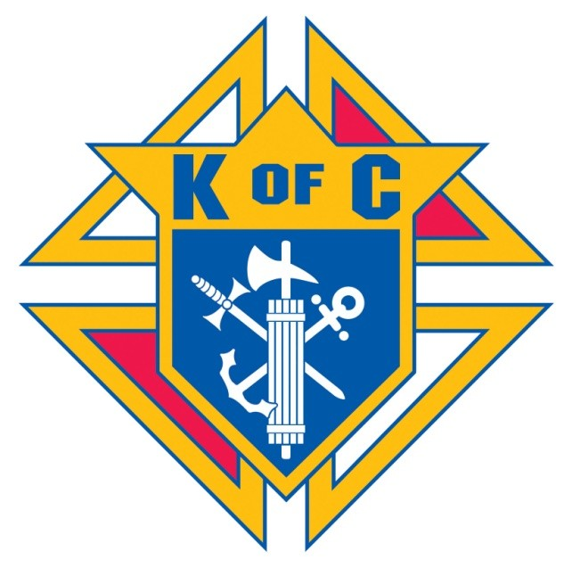

Council # 12327
St. Anthony of Padua
Catholic Church
The Woodlands, Texas

Discover a World of
Good Things in the
Knights of Columbus

